Wading through the Wetlands

*A study of the effectiveness of New Jersey’s Wetlands at filtering bacteria*

Francis Polignano, Danielle Radomile, Kate Wister

Dept. of Geography and the Environment, Villanova University, 800 E Lancaster Ave., Villanova, PA 19085.

**Abstract:**

Water quality along coastal regions has become an issue of concern as urban and agricultural development continues to increase and contribute to water pollutant levels. A form of pollution, bacteria not only degrades the quality of aquatic ecosystems but can also pose serious threats to human health. This study, which was part of a larger investigation of coastal pollution, focused on the levels of three types of bacteria, *E. coli*, Coliform and Listeria. Samples were collected from 6 strategically chosen sites within a 10 square mile wetland area in Cape May, New Jersey and measured for bacteria in an attempt to a) test the effectiveness of the 10 square mile wetland area at removing pollutants and b) identify source points of pollution. Listeria was not found at any of the 6 sites while Coliform was found at all 6. *E. coli* was found at 5 of the 6 sites. Sites 2 and 6 were found to have the highest levels of bacteria. While this differs slightly from the original hypothesis of sites 1, 2 and 4 having the highest levels of bacteria, it is believed the high levels of bacteria found at site 6 can be explained by daily tidal fluctuations of a nearby inlet, the low levels at site 4 can be explained by natural wetland filtering and the low levels at site 1 can be explained by the absence of heavy agricultural and urban development.

**Introduction:**

As human development along coastal regions of the East Coast grows, it becomes increasingly important to monitor levels of pollution. Wastewater inputs, nutrient pollution, and land surface modification often introduce various pollutants into nearby waterways, including bacteria and nutrients (Wigand et al., 2014). A form of pollution, bacteria, including Coliform, *E. coli* and Listeria, not only degrade the quality of aquatic ecosystems but can also pose serious threats to human health. Coastal wetlands in particular are susceptible to pollution as they usually act as a buffer zone between undeveloped and developed areas. Wetlands are of great ecological importance; they provide a key habitat for migratory birds, offer protection from storms and floods, naturally filter out pollutants, and are both aesthetically and recreationally pleasing (Montalto and Steenhuis, 2004). **Wetlands are among the most productive habitats in the world (**Novitizki et al., 1997**).**

In coastal environments that are frequently utilized for recreational purposes, bacteria pollution is of increased concern (Noble et al., 2003). Both agricultural and urbanized lands contribute to bacteria pollution. Livestock waste contains fecal coliform and *E. coli* that can be delivered into nearby waterways through both direct and indirect pathways (Koirala et al., 2008).  The three main conduits of animal waste into aquatic ecosystems are overland flow, subsurface flow, and direct deposit (Collins, et al., 2005).  Human waste also contains fecal coliform and can infiltrate waterways through septic leakage and inefficient wastewater treatment.  If consumed, fecal coliform bacteria can cause health problems including diarrhea, gastrointestinal disease, and kidney distress.  Listeria, unlike *E. coli* and Coliform, is a foodborne pathogen which although more rare, has a fatality rate of 30% for “at risk” people and can grow in a number of diverse environments (Ramaswamy et al., 2007).

Wetlands are ways in which pollutants like sediment, nutrients, and certain heavy metals can be removed cheaply, effectively and with little environmental impact (EPA 2004). Wetlands protect drinking water by filtering out pollutants, chemicals, and sediments however, their importance is often overlooked. If pollution inputs are not minimized, wetlands will become threatened and a source of natural pollutant filtering will disappear leading to the possibility of more pollutants being able to contaminate water sources.

In this study we investigated the levels of *E. coli*, Coliform and Listeria at 6 strategically chosen sites within a 10 square mile wetland area in Cape May, New Jersey in an attempt to test the effectiveness of the 10 square mile wetland area at removing pollutants and identify source points of pollution. Our sites included 3 locations on the northwest end of the study area and 3 sites on the opposite, southeast end of the study area. Notable sites included a sewage treatment plant (site 3), a highly urbanized area (site 4) and a site located next to an ocean inlet (site 6). Water samples from each site were collected and measured for bacteria levels. It was hypothesized that water samples taken from highly developed agricultural areas on the northwest side of the wetland (sites 1&2) or sites located next to a highly urbanized area (site 4) would yield the highest bacteria levels because of the presence of increased human development and potential farm runoff.

**Methods:**

Six 1L water samples were collected from different locations along a 10 square mile wetland area in Cape May, New Jersey on September 28, 2014 (see figure 1). The water samples were transported back to Villanova University approximately 8 hours later where they were immediately analyzed for levels of bacteria. Each water sample was tested for 3 types of bacteria using 2 different 3M Petrifilm plates. Petrifilm plate 1 tested for Environmental Listeria while Petrifilm plate 2 tested for *E. coli* and Coliform.

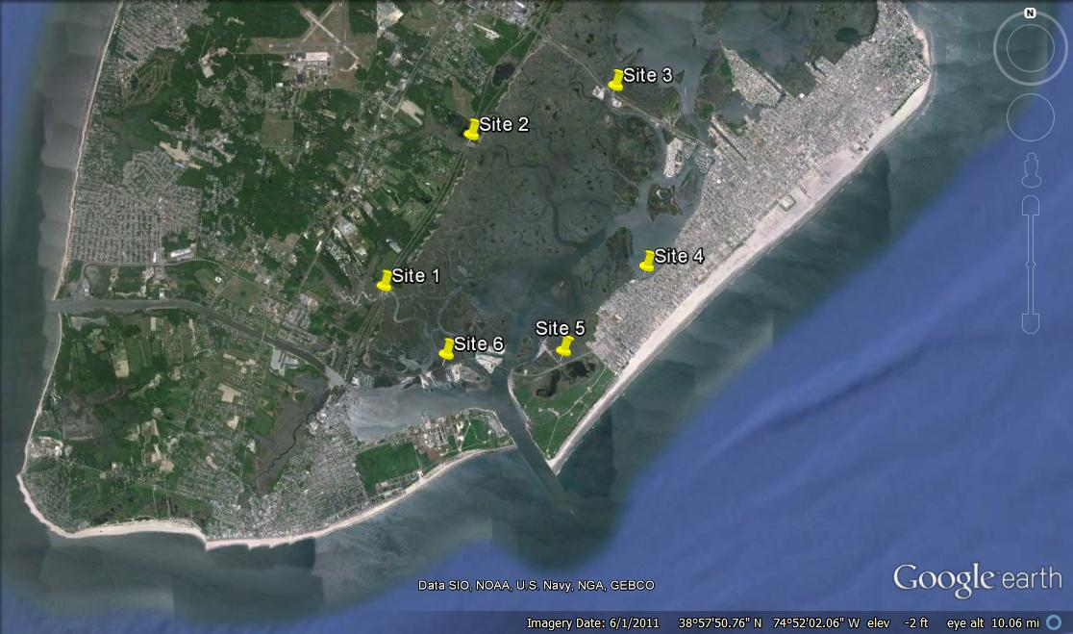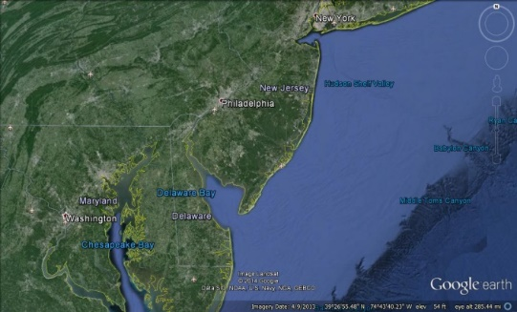

Figure . Bacteria Sample Site Locations – Cape May, New Jersey Wetlands.

Petrifilm Plate 1 – Environmental Listeria

Using a 1ml pipette, 3mL of each unfiltered water sample, as well as a control sample was placed in the center of a separate 3M Petrifilm plate. A thin film was placed over each plate and a spreader was used to evenly distribute the water sample across the plate to prevent trapping air bubbles. Each plate was incubated at 35 degrees Celsius for a period of twenty eight hours, at which time results were noted. The samples were then incubated again for another twenty eight hours, for a total incubation period of 52 hours. After the final incubation period, colonies were counted and interpreted according to the guidelines outlined in the 3M Environmental Listeria product instructions. Listeria colonies appeared as red/violet dots.

Petrifilm Plate 2 – *E. coli* and Coliform

Using a 1ml pipette, 1mL of each unfiltered water sample, as well as a control sample was placed in the center of a separate 3M Petrifilm plate. A thin film was placed over each plate and a spreader was used to evenly distribute the water sample across the plate to prevent trapping air bubbles. Each plate was incubated at 35 degrees Celsius for a period of 24 hours. After the incubation period, colonies were counted and interpreted according to the guidelines outlined in the 3M *E. coli*/Coliform product instructions. *E. coli* colonies appeared as dark red/black spots and Coliform appeared as small red dots.

**Results:**

Bacteria levels were highly variable among different locations but correlation was found with different types of bacteria. Sites 2 and 6 produced the highest bacterial levels of both *E. coli* and Coliform. (See figure 2-5). No Listeria colonies were found at any of the 6 sites.

Coliform levels spiked at site 2 with a total of 330 colonies, fell back down at site 3 and positively trended up from site 3 to site 6 (see figure 2&3).

Figure 2. Number of Coliform Colonies by Location

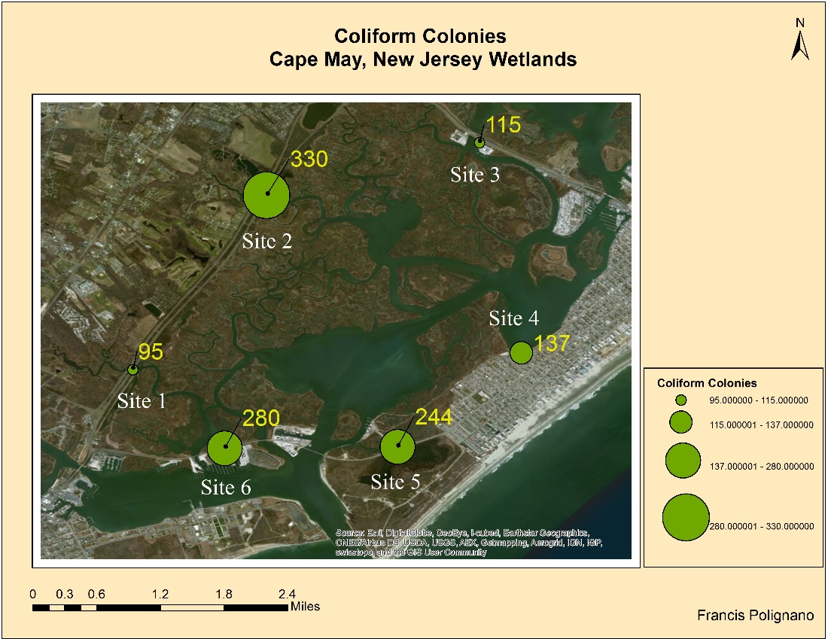

Figure 3. Map depicting Coliform Levels – Cape May, New Jersey

*E. coli* levels were variable, with no distinct trend. Sites 2 and 6 had the largest number of *E. coli* colonies. Site 1 produced the lowest number of colonies with 0 and Site 6 produced the highest with 13 colonies (See figure 4&5).

Figure 4. Number of *E. coli* Colonies by Location

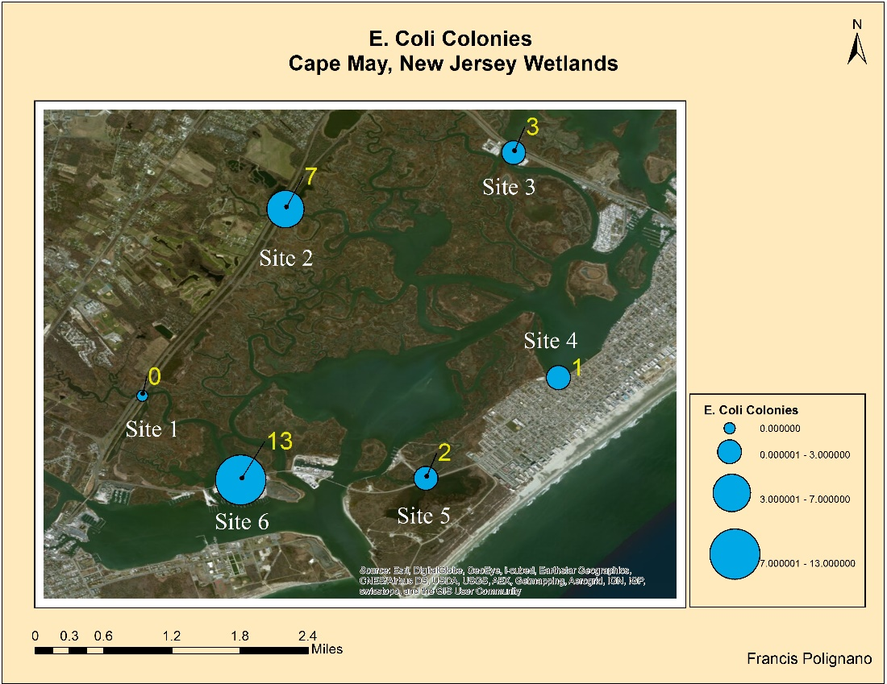

Figure 5. Map Depicting *E. coli* levels – Cape May, New Jersey

**Discussion:**

The results of this study showed that sites 2 and 6 had the largest levels of *E. coli* and Coliform. Listeria was not found at any of the 6 sites. While this differs slightly from our original hypothesis of sites 1, 2 and 4 having the highest levels of bacteria, we believe the high levels of bacteria found at site 6 can be explained by daily tidal fluctuations of a nearby inlet, the low levels at site 4 can be explained by natural wetland filtering and the low levels at site 1 can be explained by the absence of heavy agricultural and urban development.

Site 1 was initially chosen due to what we thought was the potential for high pollutant levels caused by nearby agriculture. Upon arriving to site 1, it became evident that the nearby agriculture that we thought would influence the pollution levels, was well over 100 yards away and separated by 4 lanes of highway. This is the most probable explanation for the absence of *E. coli* and relatively low levels of coliform found at site 1. Site 2 was found, as hypothesized, to have high levels of bacteria with 7 colonies of *E. coli* and 330 colonies of Coliform (Figs. 2&3). Site 2 was chosen for the same reasons as site 1, with the only difference being it was parallel to a golf course which was predicted would increase pollutants. Site 3 was not expected to produce high levels of bacteria due to its proximity to a local sewage treatment plant as well as its absence of urban and agricultural development. Our results agreed with our hypothesis. Site 4 was hypothesized to have high levels of bacteria, however our data says otherwise. The original thought behind picking site 4 was that all pollutant levels would be higher due to its close proximity to urban development. Of all our sites, site 4 was the most urbanized. Possible explanations for the observed low levels of bacteria include, natural filtering occurring in wetlands, strict water quality standards enforced by local townships and lack of agriculture. Site 5 was predicted to have low levels of bacteria and our data agrees with that statement. Site 6 briefly mentioned above, was hypothesized to have low levels of bacteria due to its lack of urban and agricultural development. Our results were the complete opposite, with site 6 having the highest number of *E. coli* (13) and second largest value of Coliform colonies (280). The most likely explanation stems from the fact that site 6 was located very close to an inlet which experiences daily tidal fluctuations. These tidal fluctuations bring in water from the ocean, skewing the pollutant levels of the wetlands. Because of these fluctuations, the results at site 6 are more of a measure of the pollutant levels in the nearby ocean rather than the wetlands.

Overall this study found that *E. coli* and Coliform levels were highest at sites 2 and 6. Site 6 was somewhat of an outlier because it was so close to the inlet, but the high bacteria levels at the heavily urbanized site 2 and data from other sites demonstrate the functionality of wetlands as natural pollutant filters. As mentioned earlier, site 4 was expected to produce high levels of bacteria but actually produced low levels. This is an indication of natural wetlands pollutant filtering at work. As water flowed through the wetlands, pollutants like bacteria were removed in an effective, financially feasible and environmentally friendly way. Results like this legitimize the argument for preserving wetlands and provide quantitative data to back it up.

**References:**

Collins, R. Elliott, S. and Adams, R. (2005). Overland flow delivery of fecal bacteria to a

headwater pastoral stream. *Journal of Applied Microbiology,* 99: 126-32.

Koirala, S. Gentry, R. Perfect, E. Schwartz, J. and Saylor G. (2008). Temporal variation and persistence of bacteria in streams. *Journal of* *Environmental Quality,* 37: 1559-66.

Montalto, F. and Steenhuis, T. (2004). The link between hydrology and restoration of tidal

Marshes in the New York/New Jersey Estuary. *Wetlands,* 24.2: 414-425.

Noble, R. Moore, D. Leecaster M. McGee, C. and Weisberg, S. (2003). Comparison of total coliform, fecal coliform, and enterococcus bacterial indicator response for ocean recreational water quality testing. *Water Research,*37.7: 1637-1643.

Novitizki, R. Smith, D. and Fretwell J. (1997). Restoration, Creation, and Recovery of Wetlands: Wetland Functions, Values, and Assessment. United States Geological Survey Water Supply Paper 2425.

Ramaswamy, V. Cresence, V. Rejitha, J. Lekshmi, M. Dharsana, K. Prasad, S and Vijila, H. (2007). Listeria- Review of Epidemiology and Pathogenesis. *Journal of Microbiology, Immunology & Infection,*40:4-13.

U.S. Environmental Protection Agency. (2004). Wetlands Overview. Office of Water and Office of Research and Development, Washington, D.C.. Retrieved March 2, 2014, from http://water.epa.gov/type/wetlands/outreach/upload/overview.pdf.

Wigand, C. Roman, C. Davey, E. Stolt, M. Johnson, R. Hanson, A. Watson, E. Moran, S. Cahoon, D. Lynch, J. and Rafferty P. (2014). Below the disappearing marshes of an urban estuary: historic nitrogen trends and soil structure. *Ecological Applications,* 24.4: 633-649.